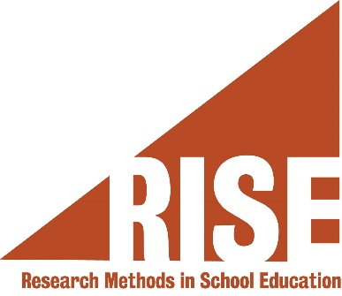

RISE Research Methods Course
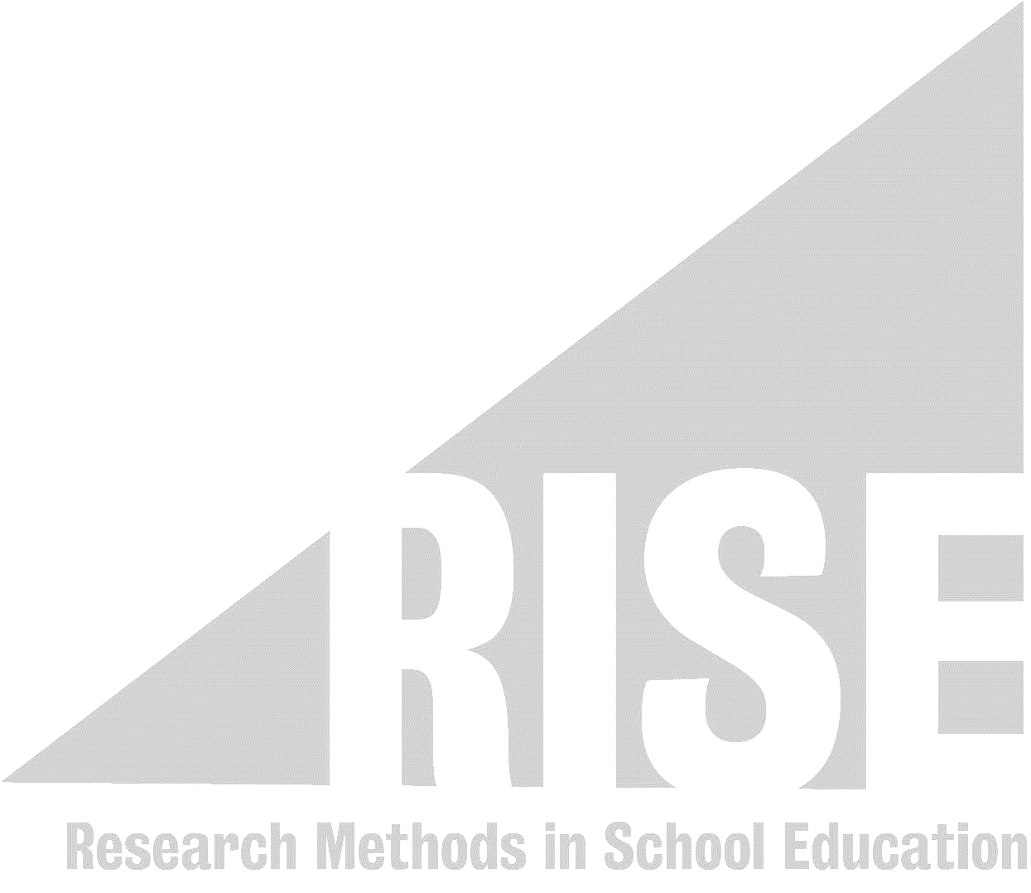
Certificate of Completion

presented to
Student Name

April 2020

Dr Charlotte Woodhead
Institute of Psychiatry, Psychology & Neuroscience

